Bug_01:
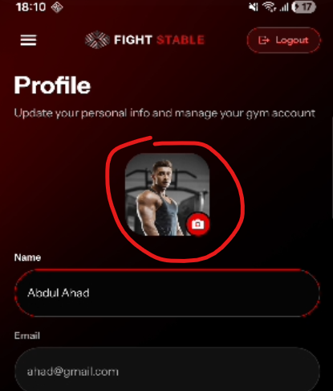
Can’t preview and remove the profile image
Bug_02:
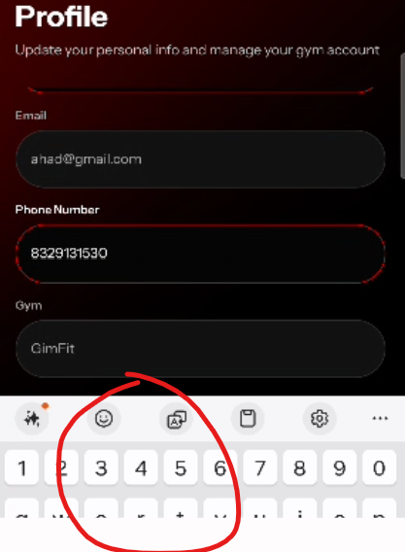
Save Profile and Change Password buttons are not visible while editing. User Have to click the back button to save profile.
Steps To Reproduce:
- Go to Profile page.
- Click on edit profile.
- now edit your profile
- scroll down to save changes
- save profile button is not visible

Bug_03:
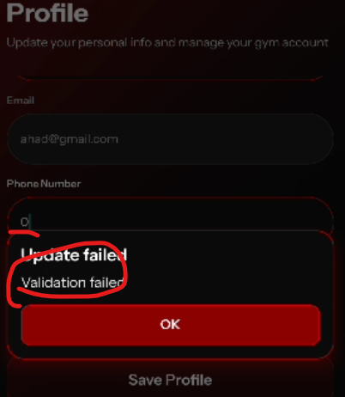
No proper error message shown when phone number set to 0.

Bug_04:
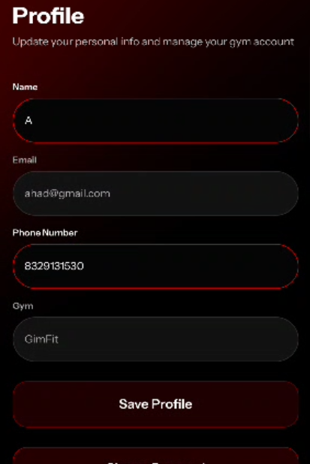
Inconsistency Issue

Steps To Reproduce:
- Go to profile page and click on edit profile.
- Now, go to Add Member / Stripe page and then comeback to profile page. Edit profile is activated.
- Now, go to Home / Members page and then comeback to profile page. Edit profile is de activated.

Bug_05:
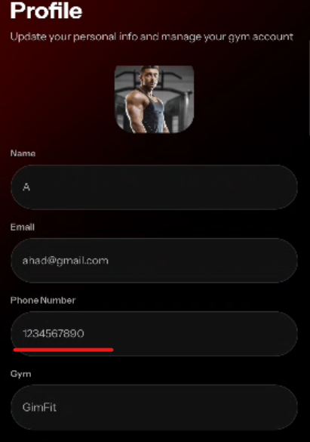
While editing, Phone number changes to any number without any validation and authentication.

Bug_06:
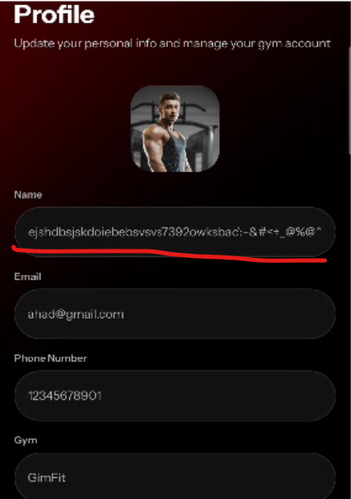
Name changes to any name without any validation.

Bug_07:
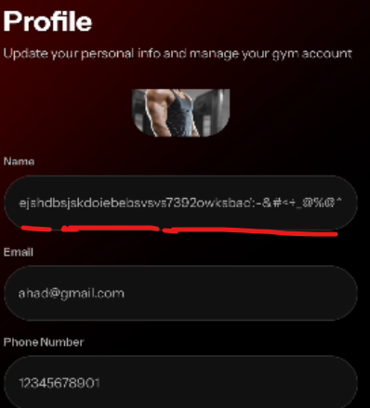
After updating the profile name and phone number, it still shows the old name does not refresh the page

Bug_08:

Navigation between pages has no smooth transition; screen changes abruptly like a flash.

Bug_09:
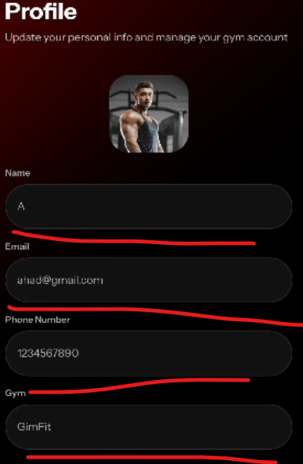
Profile Page Fields should have a red border color and rectangular like shape as per figma design.

